Deerwalk Institute of Technology

Sifal, Kathmandu

Artificial Intelligence Practical - 9

Submitted By: Submitted To:

Name: Sagar Giri Sudan Prajapati

Roll No: 205

Section: A

Date:

1. Read, Write & built-in predicates in prolog

Predicate **write(term)** causes a term to be written to the current output stream (the monitor screen by default). X will be output in the same standard syntactic form in which prolog normally displays values of variables. A useful feature of prolog is that the write procedure ‘knows’ to display any term.

Predicate **read(term)** is used to read a term from the current input stream (the keyboard by default). The goal read(X) will cause the next term T, to be read which match with X. If X is a variable then X will be instantiated to T. The predicate read is deterministic.

Another built-in predicate **tab(N)** causes N space output whereas predicate **nl** causes the start of a new line output.

**Some results:**

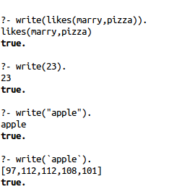

**Fact:**

likes(simona,bibek).

likes(bibek,simona).

**Output:**

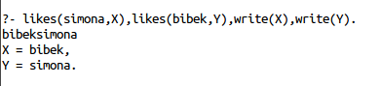

Read Task

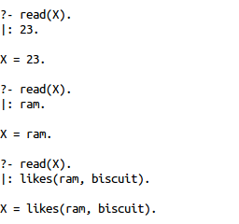

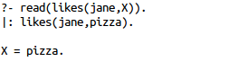

**Example for tab(N) and nl**

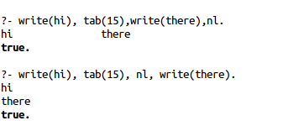

Predicate PUT. Writes the character C on the current output stream.

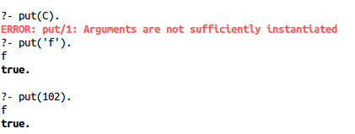

Predicate **get** and **getbyte**: read a single character from the current input stream use get_byte(C), where C is a variable.

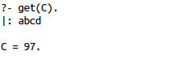

**Example: Read a character and print its ASCII.**

**Fact:**

read_a_char(C) :- write('Type: '), flush_output, get(C).

**Output:**

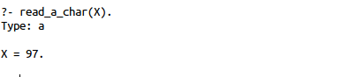

**Example: Read and write to find the cube of a number.**

cube:- write('Please enter a number: '), read(N), process(N).

process(stop):-!.

process(N):- C is N * N * N, write('Cube of '),write(N),write(' is '),write(C),nl,cube.

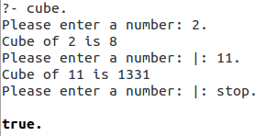

**Writing a list**

writelist([]).

writelist([X|L]):-write(X),nl,writelist(L).

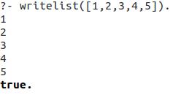

**I/O in Prolog**

position(‘Spielberg’, director).

position(‘Allen’, manager).

position(‘Lee’, supervisor).

find_position:- write(‘Whose position do you wish to know?’),

read(Input),

position(Input, Output),

write(‘The position of ‘),

write(Input),

write(‘ is ‘),

write(Output),

write(‘.’).

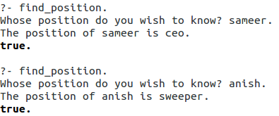

**Q. Enter the two numbers from the user and find the greatest among them**

greatest:- write('Please enter number 1: '), read(N1),

write('Please enter number 2: '), read(N2), process(N1,N2).

process(N1,N2):- N1 > N2, write(N1), write(' is Greatest number.'),!.

process(N1,N2):- N2 > N1, write(N2), write(' is Greatest number.').

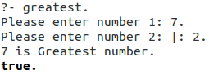

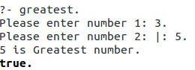

**Q. Write the output of**

put(65).

put(66).

put(67).

get0(c)

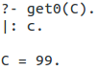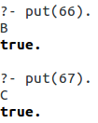

**Q. Suppose Ashim is Cr of class, Sachin is programmer , Prabina is librarian and john is hacker write a prolog program to find their specialty.**

speciality(ashim,cr).

speciality(sachin,programmer).

speciality(prabina,librarian).

speciality(john,hacker).

find_speciality:- write('Enter name: '),

read(Input),

speciality(Input,Output),

write('The speciality of '),

write(Input),

write(' is '),

write(Output),

write(',').

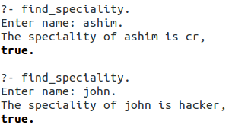

**Q. Write a prolog program to find the position of the corresponding DWIT staff name.**

position(surendra,principal).

position(hitesh,cao).

position(bijay,academic_coordinator).

position(amrit,accountant).

position(shivangi,librarian).

find_position:- write('Whose position do you wish to know? '),

read(Input),

position(Input,Output),

write('The position of '),

write(Input),

write(' is '),

write(Output),

write('.').

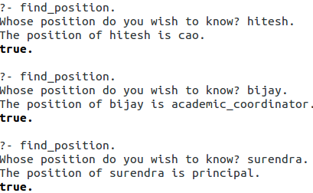

**Q. Write a prolog program to write a list of list program [hint[[a,b,c],[d,e.f]]]**

writelist([]).

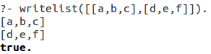writelist([X|L]):-write(X),nl,writelist(L).